**STATEMENT OF COMPLETENESS**

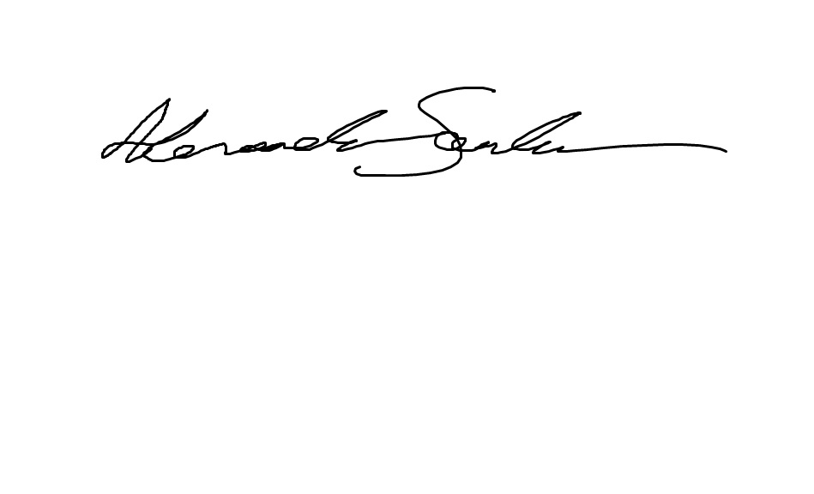**I, Alexander Santander hereby declare that this document and all that pertains to it was solely completed by my partner and I, of which I contributed roughly 50%**

**I, Hrushikesh Lakkola hereby declare that this document and all that pertains to it was solely completed by my partner and I, of which I contributed roughly 50%**

